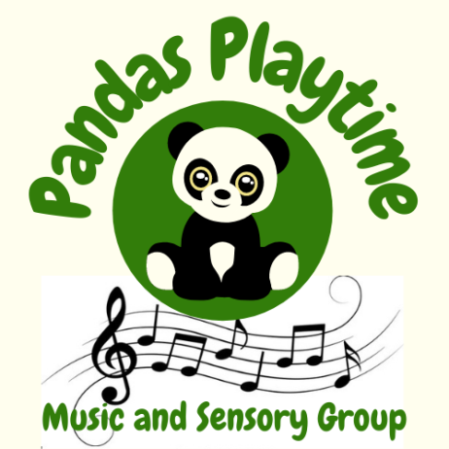
Terms and Conditions
The health, safety and wellbeing of all Panda’s Playtime attendees are paramount. We make our setting a safe place for children, parents and carers. Please take a minute to read our terms and conditions in order to enjoy safe Pandas Playtime sessions.
- Your child(ren) remain(s) your responsibility at our sessions, and must be supervised at all times. If you need to leave the room for any reason, please take your child with you. You are responsible for the behaviour of your child(ren).
- We politely ask that you do not attend if you or your child is suffering from a contagious illness or complaint.
- We regret that there will be no discount or refund for pre-paid classes that you do not attend. If, however, in the unlikely event that Pandas Playtime has to cancel a session for any reason, a full refund or credit for a future class will be given.
- All props are distributed in the knowledge that they are used under a parent or carer's supervision.
- Pandas Playtime accepts no liability or responsibility for any loss or damage to your property or belongings.
- You accept responsibility and will indemnify us for any expenses for damage to or loss of our or the venue owner's equipment, products or property, caused or incited by you.
- We reserve the right to suspend attendance at our classes for any child for whom you have not paid for.
- We hope that our sessions are of a high quality. Please contact us if you have any complaints or suggestions.
- This agreement is governed by English Law and is subject to the exclusive jurisdiction of the English courts.
We hope that you enjoy our Pandas Playtime sessions as much as we enjoy running them.

